Function: 1

Function: 2 get_testuser_info() result

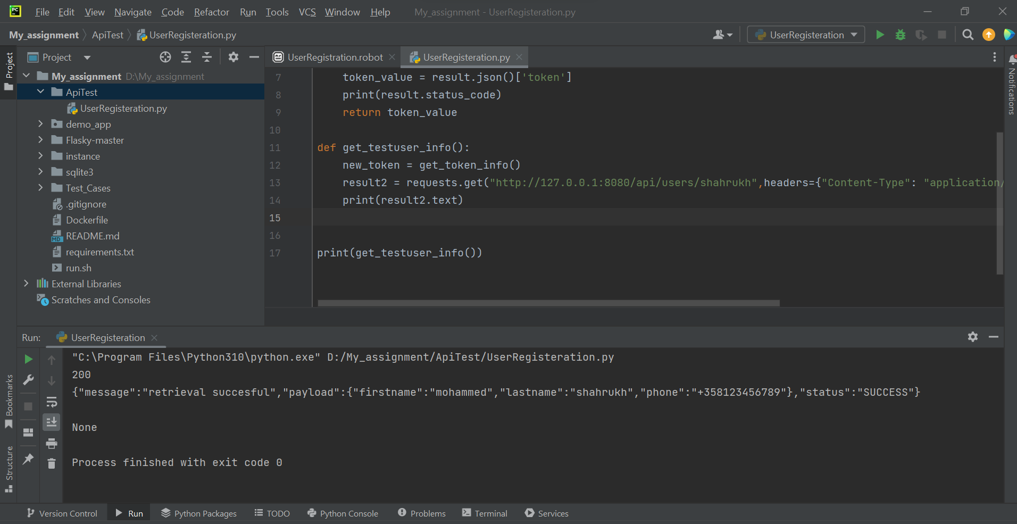

Function 3 get_all_user_info() result below

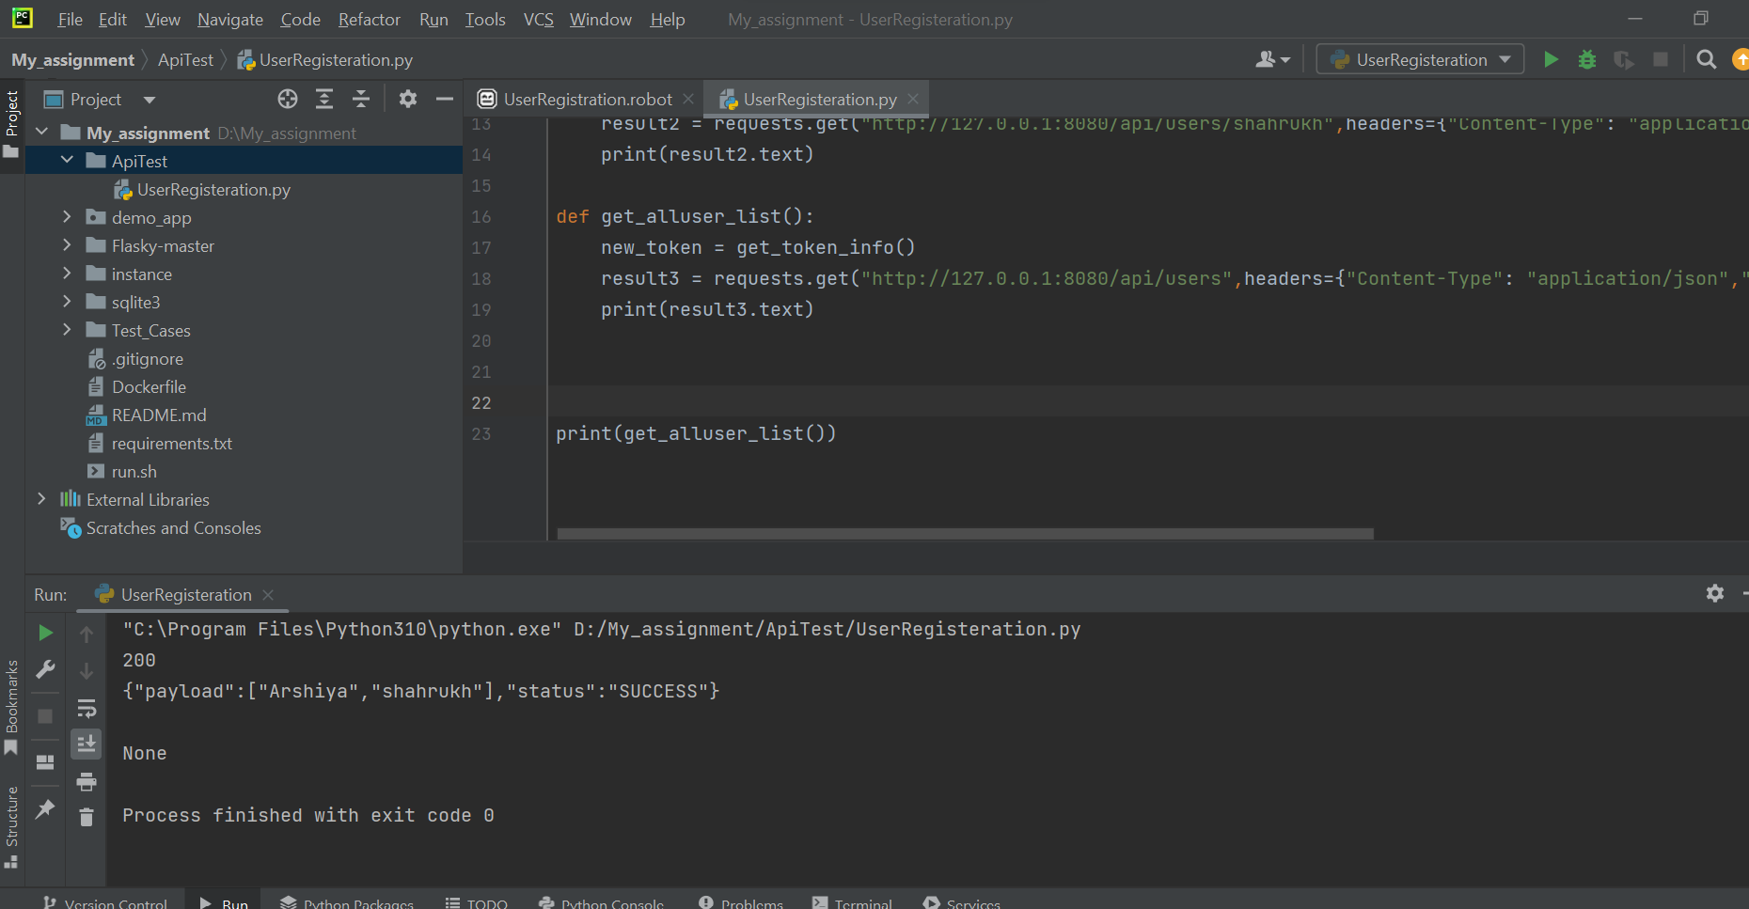

Function: 4 post_newuser()

Result is failing with 401 error

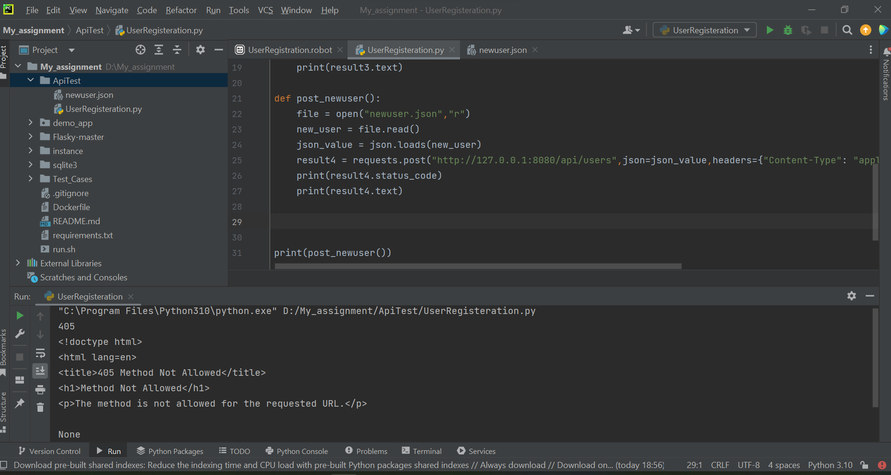

Function 5: Put user_edit()

Failing result attached below

